Agitprop Theatre

Now widely used as a catch-all term to describe politically combative or oppositional art, ‘agitprop’ originated from the early Soviet conjunction of propaganda (raising awareness of an issue) and agitation (exciting an emotional response to the issue), as theorized by Lenin in What Is To Be Done (1902) and institutionalized in the many departments and commissions of Agitation and Propaganda in the USSR and the Comintern after the Russian Revolution. The portmanteau term conveys the terse telegraphic efficiencies of Bolshevik bureaucratic rhetoric. Considered both as a mode of artistic production and a set of formal characteristics, agitprop had an immense impact on modernist cultural practice, particularly in graphic design, visual art, and theatre.

In the theatre, agitprop developed in Russia and Germany as a mobile form of exhortative revolutionary theatre designed for quick outdoor performance. It was adaptive to location, audience, and cast, and suited the sightlines and acoustics of outdoor performance in found spaces. Short phrases, heavy cadence, and repetition allowed performance to project through noisy and unruly audiences. The form achieved widespread popularity in the brief period between the mid-1920s and the coalescence of the Popular Front in 1934, when artistic and political radicalisms aligned in a vision of an artistic practice mobilized by international proletarian modernity; in this, agitprop was theorized as the theatricalization of modernity.

The spread of agitprop as a principal tactic of the Workers’ Theatre Movement began with the adaptation of German practices in North America and Europe. A formative figure was Hans Bohn, a German communist activist who moved to New York to organize in the German community, changed his name to John Bonn, and founded Prolet-Buehne in 1925. Prolet-Buehne’s drilled, choreographic performances, with emphasis on choral recitations and mass chant, established a template for agitprop troupes such as the Shock Troupe of the Workers’ Laboratory Theatre in New York and the Toronto-based Workers’ Experimental Theatre. Bonn also founded the magazine Workers Theatre and established the League of Workers’ Theatres, which functioned as the organizational and ideological centres that linked the North American workers’ theatres to the Comintern.

At its peak, encouraged by the Comintern, agitprop was proposed as a new form of proletarian modernism. One of the most important articulations of its theory was Al Saxe’s 1934 essay ‘Newsboy: From Script to Performance,’ which theorized the play’s fusion of fragmented dialogue, imagery, rapid movement, and repetition as a performance machine driven by dialectic and tempo rather than dramatic causality. The notion of agitpop as evidence of trans-national proletarian culture led to its centrality in mass competitions, such as the 1932 Spartakiade in New York and the 1933 Revolutionary Theatre Olympiad in Moscow, in which troupes were scored on the basis of technical competence, tempo, movement, and ideological clarity.

Despite such attempts to systematize agitprop, radical performance proliferated in a vast number of forms, including puppetry, vaudeville, and ballet. By the mid-1930s, a growing tendency towards more complex dramatic models stigmatized agitprop as immature and politically sectarian. As later recalled by Ewan MacColl, who had started performing agitprops in the late 1920s in Manchester with his troupe Red Megaphone, artists began to seek ways to make their work more theatrically complex and dramatically intelligent. This shift had the effect of taking them off the streets and into theatre spaces that enabled experimentation with scenography and design. The waning of militancy that marked the arrival of the Popular Front nudged radical groups to tone down the rhetoric of class war. The proponents of agitprop attempted to mediate the emergence of Popular Front social realism; thus, Bonn wrote in 1932 that ‘we need both types as weapons in the class struggle, the flashlight effect of the mobile up-to-date agit-prop theatre as well as the impetus of the slower but broad attack of the more complicated stationary theatre’ (‘Situation and Tasks’ 8). As radical troupes realigned their politics, Clifford Odets’s Waiting for Lefty (1935) circulated internationally as a useful bridge from agitprop to the new doctrine of socialist realism.

Although workers’ theatre groups repudiated agitprop as inartistic and sectarian, Bertolt Brecht demonstrated its pedagogical capacity in his lehrstucke, particulary in The Measures Taken (1930). In the 1960s, a widespread revival of agitprop, variously known as street theatre or guerilla theatre, became a common counter-cultural protest tactic that continues in the present day.

References and Further Reading

Bonn, John. (1932) ‘Situation and Tasks of the Workers Theatre in the U.S.A.,’ Workers Theatre (June-July): 8.

Brecht, Bertolt. (1997) The Decision [The Measures Taken], Collected Plays: Three, ed. and trans. John Willett, London: Methuen.

Levine, Ira A. (1985) Left-Wing Dramatic Theory in the American Theatre, Ann Arbor: UMI.

Endres, Robin, and Richard Wright. (eds.) (1976) Eight Men Speak and Other Plays from the Canadian Workers’ Theatre, Toronto: New Hogtown.

MacColl, Ewan. (1990) Journeyman: An Autobiography, London: Sidgwick & Jackson.

Saxe, Al. ([1934] 1985) ‘Newsboy: From Script to Performance,’ reprinted in Theatres of the Left: 1888-1935; Workers’ Theatre Movements in Britain and America, ed. Raphael Samuel, Ewan MacColl, and Stuart Cosgrove, London: Routledge & Kegan Paul, 289-296

Stourac, Richard, and Kathleen McCreery. (1986) Theatre as a Weapon: Workers’ Theatre in the Soviet Union, Germany and Britain, 1917-1934, London: Routledge and Kegan Paul.

Alan Filewod, University of Guelph
Recommended Illustrations

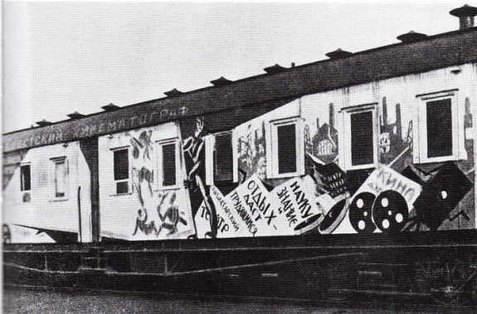
An early Soviet agitprop train.
[Source: http://275design.wordpress.com/2010/12/07/8-dec-propaganda-and-protest/]

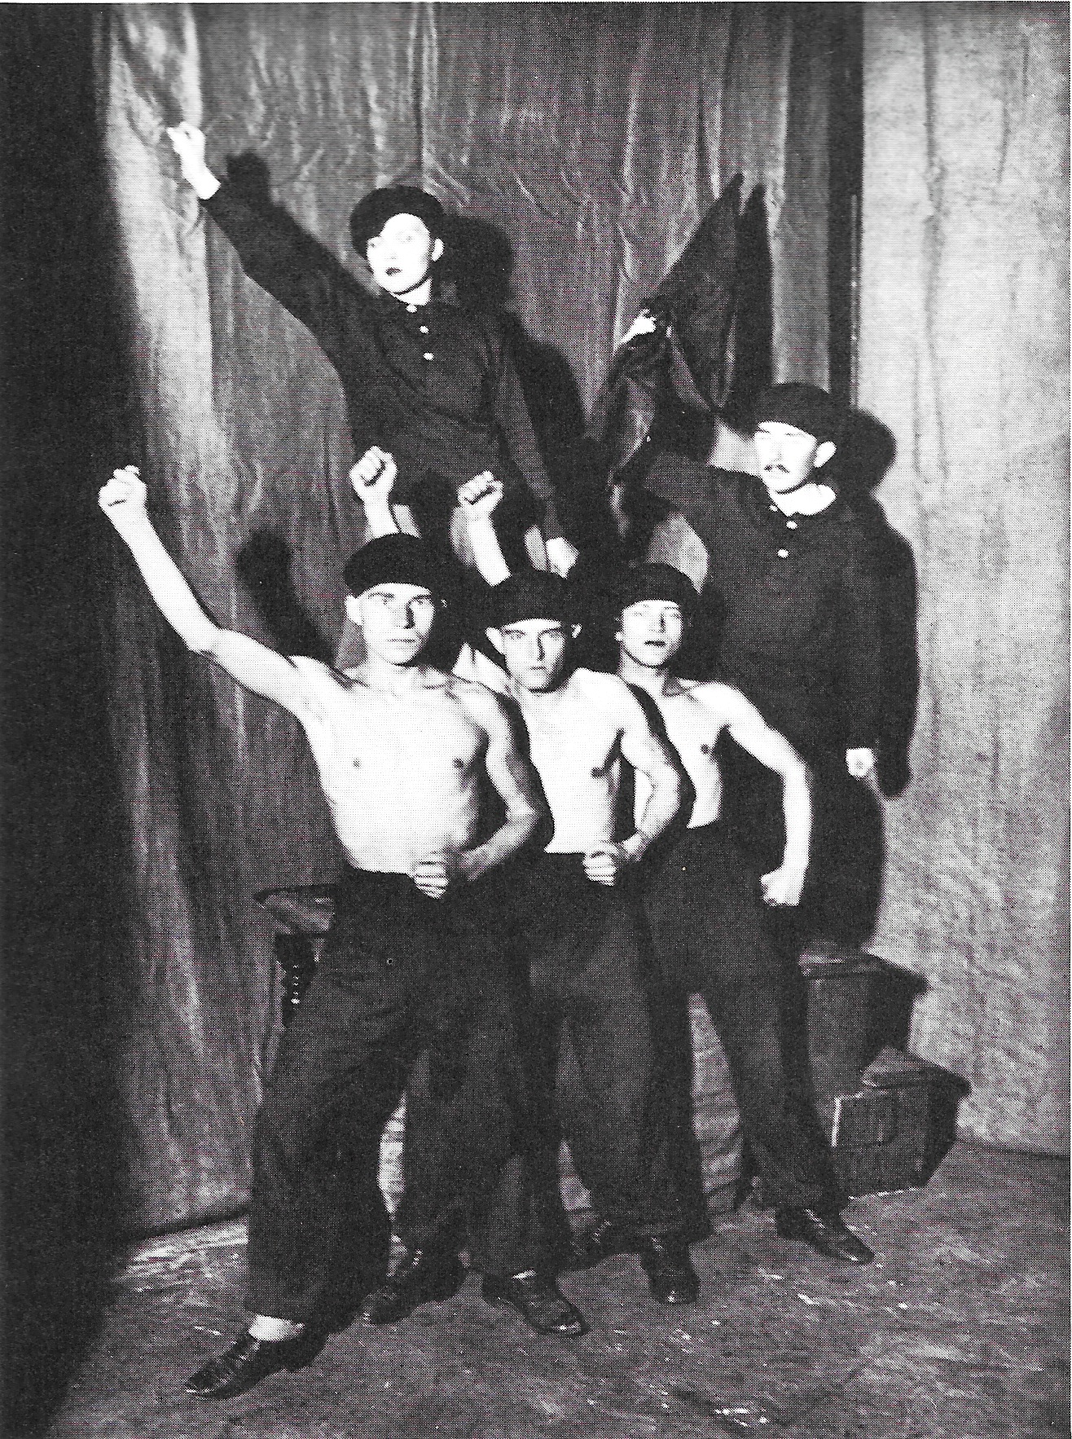

The Drummers, a German agitprop troupe.
[Reproduced in Willett, John. (1978) Art and Politics in the Weimar Period, New York: Pantheon: 157.]

